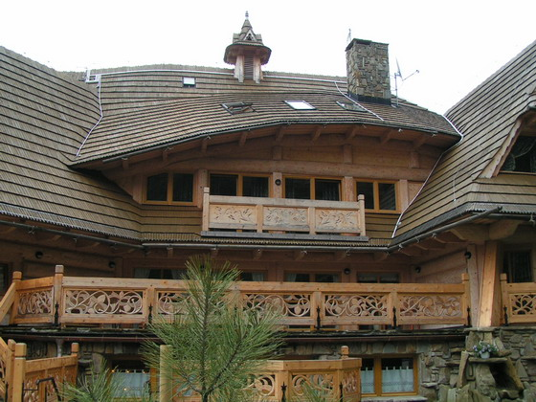 | QUANTUM  and  COMBINATORICS  Zakopane (Tatra Mountains, Poland) 12, 13 and 14 Nov. 2009 | Andrzej Horzela  Department of Theoretical Astrophysics  H.Niewodniczanski Institute of Nuclear Physics, Polish Academy of Sciences  ul.Eliasza - Radzikowskiego 152, 31342 Krakow, Poland  tel.+48 12 662 83 83, fax:+48 12 662 84 58, home:+48 12 413 47 63  e-mail: Andrzej.Horzela@ifj.edu.pl mob: +48 605 071 814
Dear Colleague:
This 3-day workshop is intended to cover some recent developments in Quantum Theory, emphasizing algebraic and combinatorial methods.
Mindful of your expertise in a relevant area, we are happy to invite you to attend this meeting, which will be limited to 30 participants, and present a talk on a topic of your choice (40+5 minutes).
The meeting will take place in a new conference center " Marymont" of the Warsaw Agricultural University, in Zakopane, near the Koscieliska Valley.

We shall of course pay your accomodation expenses (full board) while you are in Zakopane, but are unfortunately unable to reimburse travel costs.

Participants are asked to arrive in Krakow not later than on 11th Nov. afternoon. The bus transfer from
Krakow to Zakopane will be provided on 11th Nov..
More details will be sent in a forthcoming circular.
Looking forward to your attendance,

Andrzej Horzela
(for the organising team: A.Horzela, P.Blasiak, A.I.Solomon, G.H.E.Duchamp and K.A.Penson)
-----------------------------------------------
Andrzej Horzela
Department of Theoretical Astrophysics
H.Niewodniczanski Institute of Nuclear Physics, Polish Academy of Sciences
ul.Eliasza - Radzikowskiego 152, 31342 Krakow, Poland
tel.+48 12 662 83 83, fax:+48 12 662 84 58, home:+48 12 413 47 63
e-mail: Andrzej.Horzela@ifj.edu.pl mob: +48 605 071 814

